


Movie Recommendation – CPIT 440

With Deep Respect, Submitted to Dr. Mahmoud
Department of Information Technology
At King Abdulaziz University (KAU)

Phase 2 - Comprehensive Report
Muath Abbas Eissa [2338818]
Meshal Ahmad AlAjlani [2335521]
Hashim Yaser Bajaber [2336321]
Mohammed Khalid Alahmadi [2340345]

Date of Submission
6th December 2025

Contents
Introduction 3
Problem 3
Goal 3
Data Exploration 4
Data Mining Formalization 4
Type of Data 4
Splits (Train-Test) 5
Within-Cluster Sum of Squares (WCSS) 5
Silhouette Score 5
Source of Data 6
Visualization 6
Histogram - Rating Distribution 6
Boxplot: Release Year 6
Scatter Plot: Runtime vs Rating 7
Correlation Study 7
Data Preprocessing 7
Data Preparation Details 7
Train / Test Split 8
Feature Selection 8
Models Training 9
Algorithms Used 9
Cross Validation 9
Models Evaluation 9
Performance Metrics 9
Model Performance Comparison 10
Model Selection and Justification 10
Tools and Libraries 10
Difficulties / Challenges 10
Future Work 11
Work Division Table 11
References 11

Figures
Figure 1 - Kaggle Dataset Description 6
Figure 2 - Histogram - Rating Distribution 7
Figure 3 - Boxplot: Release Year 7
Figure 4 - Scatter Plot: Runtime vs Rating 7
Figure 5 - Correlation Study 8
Figure 6 - Merging fields 8
Figure 7 - CountVectorizer Example 9
Figure 8 - Sillhouette Score Scale 10

Introduction
This project applies K-Means clustering to demonstrate core data mining techniques on an IMdb movie dataset. We combine textual features (genres) with scaled numerical attributes (ratings, runtime) to create a unified feature representation for 5,562 films. K-Means partitions this feature space into 180 clusters, grouping movies with similar characteristics. While the resulting clusters can suggest movies from the same group, the primary focus is on illustrating how data preprocessing, feature engineering, and unsupervised learning techniques combine to extract patterns from mixed-type data. This project serves as a practical exploration of data mining methodology rather than a production-ready recommendation solution.

Problem
With large movie datasets, identifying patterns and similarities across multiple attributes presents a data exploration challenge. While various recommendation approaches exist, this project uses clustering as a practical demonstration of how data mining techniques can be applied to organize and structure movie data based on both content and numerical features.

Goal
The goal of this project is to demonstrate the application of data mining techniques—specifically clustering algorithms—to organize movie data. By combining genre information with numerical attributes (rating, runtime) and applying K-Means clustering, we explore how unsupervised learning can identify structural patterns in movie datasets. The resulting clusters provide a foundation for basic recommendations, with the primary focus on understanding how data preprocessing, feature engineering, and clustering techniques work together.

Data Exploration

Data Mining Formalization
This project is formulated as a clustering task.
The K-Means algorithm is used to group movies based on both content-based attributes and numerical features. Since machine learning algorithms cannot process text directly, the genre information (Main Genre and Side Genre) is converted into numerical vectors using CountVectorizer. This transformation enables the algorithm to evaluate similarity between movies based on their genre descriptions.
In addition to the genre vectors, numerical attributes such as Rating and Runtime (in minutes) are included in the feature set. By combining these numeric features with the genre vectors, the model can cluster movies based on both content similarity and quantitative differences, resulting in meaningful and well-separated groups.
Other dataset attributes, such as Director, Actors, Year, or Total Gross, were not used in clustering.

Type of Data
The dataset contains movie metadata, including:
Attribute | Example / Description | Feature Type
Movie title | The Dark Knight | Textual
Year | 2008 | Numerical (int64)
Director | Christopher Nolan | Textual
Actors | Christian Bale, Heath Ledger | Textual
Rating | 9.0 | Numerical (float64)
Runtime (in minutes) | 152 | Numerical (int64)
Censorship classification | PG-13 | Textual
Total gross | 1,005,000,000 | Numerical (int64 / float64)
Main genre | Action | Textual
Side genre | Crime, Thriller | Textual
For this project, the clustering model specifically uses:
- Main Genre
- Side Genre
- Rating
- Runtime(Mins)
Although Movie_Title exists in the dataset, it is not used as a feature for clustering. It is only used to identify and match movies when generating recommendations.

Splits (Train-Test)
Since this project applies unsupervised clustering using K-Means, a train-test split was not required. Unlike supervised learning tasks, clustering does not rely on predefined labels, so all movies in the dataset were used to fit the model.
Instead of splitting the data, the quality of the clusters was evaluated using internal validation metrics, such as:
Within-Cluster Sum of Squares (WCSS)
Measures of how tightly grouped the movies are within each cluster.

Silhouette Score
Measures how well-separated the clusters are and how similar movies are within the same cluster.
All preprocessing, feature engineering, and scaling were applied to the full dataset before training the K-Means model, ensuring that the clustering results reflect the structure of the entire dataset.

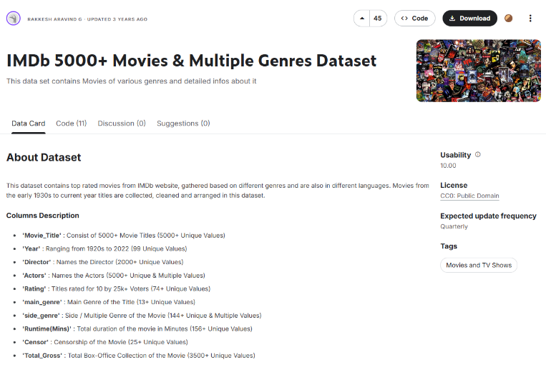
Source of Data
Figure 1 - Kaggle Dataset Description
The dataset used in this project was obtained from Kaggle: IMDB 5000 Movies – Multiple Genres Dataset.
It contains metadata for 5,562 movies, including attributes such as Movie Title, Year, Director, Actors, Rating, Runtime, Main Genre, Side Genre, Total Gross, and Censorship Classification.
This dataset was chosen because it provides a rich set of both textual and numerical features, which are necessary for building a content-based clustering model.

Visualization
To better understand the dataset and identify patterns before clustering, several visualizations were created using matplotlib and seaborn:

Histogram - Rating Distribution
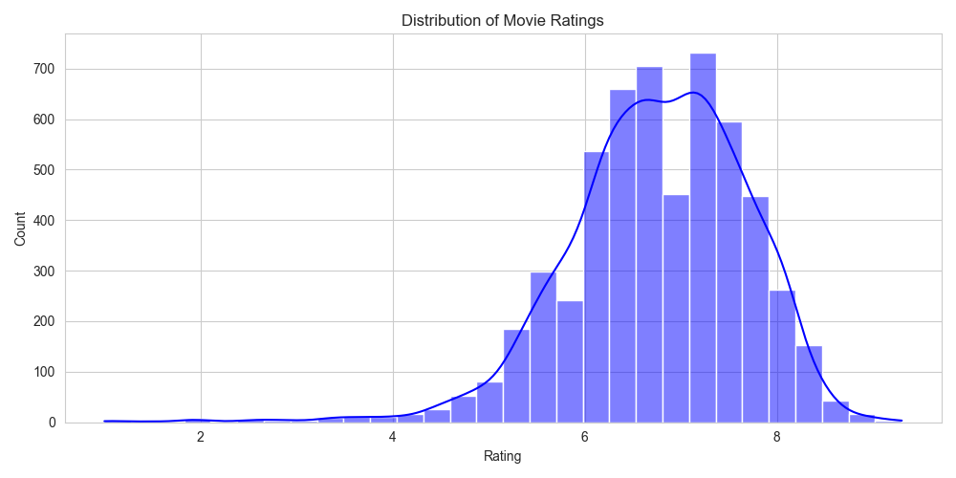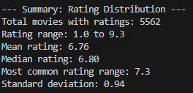
Figure 2 - Histogram - Rating Distribution
Movies have ratings from 1.0 to 9.3, with a mean of 6.76 and a most common rating around 7.3. The distribution is slightly skewed toward higher ratings.

Boxplot: Release Year
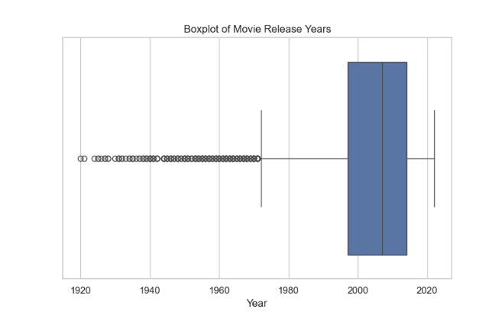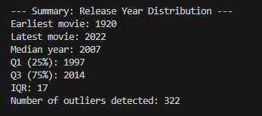
Figure 3 - Boxplot: Release Year
Movies range from 1920 to 2022, with a median year of 2007 and 322 outliers, showing a mix of older and newer films.
Scatter Plot: Runtime vs Rating
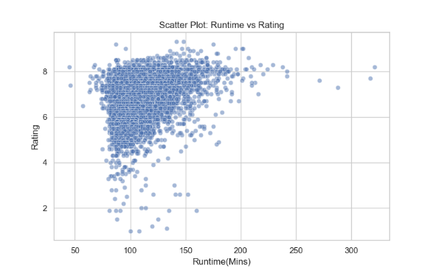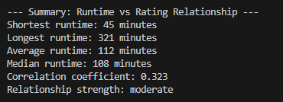
Figure 4 - Scatter Plot: Runtime vs Rating

Correlation Study
A correlation matrix was generated using numerical attributes.
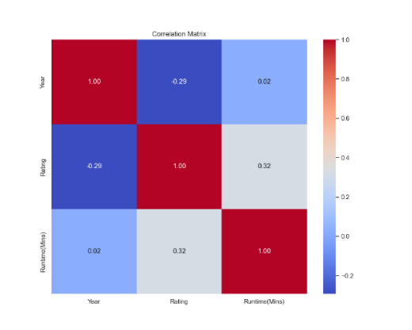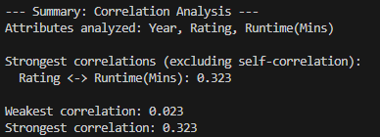
Figure 5 - Correlation Study
Runtime vs Rating (Scatter Plot & Correlation): Runtime and rating show a modest positive correlation (0.323), while Year has little correlation with runtime (0.023).

Data Preprocessing

Data Preparation Details
Data preprocessing was performed to prepare the dataset for clustering and recommendation. An initial examination of the dataset confirmed that the required attributes were complete, with no missing values in the numerical fields (Rating, Runtime(Mins), Year) and no placeholders such as "?", "Unknown", or NaN. This allowed the project to proceed without the need for imputation or removal of incomplete records.
To support clustering based on movie content, several feature engineering steps were applied. First, the descriptive attributes of each movie—such as the Movie Title, Main Genre, and Side Genre—were combined into a single text-based feature. This ensures that the model captures important contextual information about each movie in a unified form.
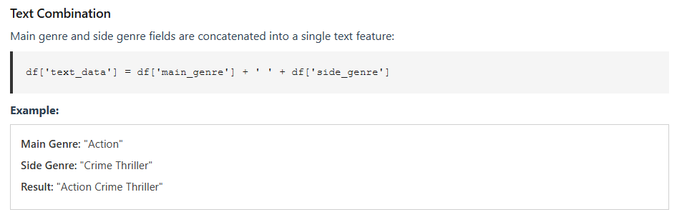
Figure 6 - Merging fields
Next, the combined text field was converted into numerical form so that it could be used by the K-Means algorithm. This step allows the model to compare movies based on their text descriptions, such as similarities in titles and genres. Movies with more similar words or categories naturally become closer to each other in the data, helping the clustering algorithm group them more effectively.
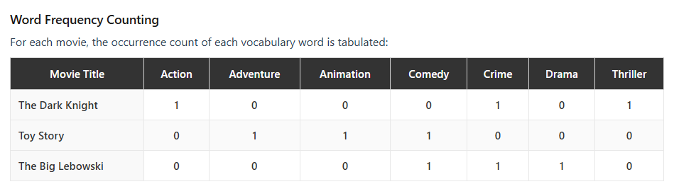
Figure 7 - CountVectorizer Example
Additionally, numerical attributes such as Rating, Runtime, and Year were included directly in the input data to preserve important quantitative differences between movies. These numeric values help distinguish films with similar text descriptions but different levels of quality, pacing, or release periods.
The final feature matrix X was constructed by combining the numerical representations of text data with the additional numeric attributes. This matrix serves as the input to the K-Means algorithm, allowing it to group movies based on both content similarity and measurable characteristics.

Train / Test Split
Since this project applies unsupervised clustering, a train–test split was not required. All movies were used in the clustering process because K-Means does not rely on labeled output data.

Feature Selection
Feature selection was carried out by choosing attributes that meaningfully describe a movie’s content and measurable characteristics. The features used for clustering were:
- Main Genre
- Side Genre
- Rating
- Runtime
The genre attributes were combined into a single text feature and transformed into numerical form using CountVectorizer, while the numerical attributes were scaled using MinMaxScaler. These numeric attributes allow the model to recognize differences between movies that share similar genre descriptions but vary in their rating level and overall duration.

Models Training

Algorithms Used
The clustering model used in this project is the K-Means algorithm. It was trained using the prepared feature matrix with the settings n_clusters = 180, random_state = 42, and n_init = 10.
To decide on the number of clusters, the Elbow Method was applied by testing several values of K and observing how the Within-Cluster Sum of Squares (WCSS) changed. Although there was no clear or strong elbow point, increasing the number of clusters helped form more meaningful groups, especially because the dataset contains many different genres and sub-genres. For this reason, K = 180 was selected, as it produced movie clusters that were more consistent and better aligned with genre-based similarities.

Cross Validation
Traditional cross-validation was not applied because K-Means is an unsupervised learning algorithm that does not depend on labeled target values. Instead, internal validation metrics were used to evaluate clustering quality.

Models Evaluation

Performance Metrics
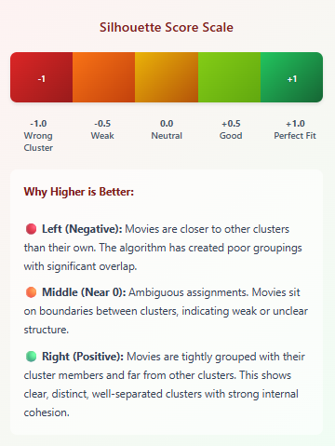
The clustering model was evaluated using two measures: the Within-Cluster Sum of Squares (WCSS) and the Silhouette Score. WCSS was calculated for different values of K to observe how the compactness of the clusters changed as more groups were added. Although the Elbow Method did not show a very clear turning point, testing several values helped understand how the dataset behaved.
Figure 8 - Sillhouette Score Scale
After selecting the final model, the Silhouette Score was computed. The score for K = 180 was 0.7947, which is high. This does not mean the model is unusually powerful; rather, it reflects the natural structure of the data. Movies from different genres tend to be very different from each other, so they form clear and separate groups. The score simply confirms that movies within the same cluster are similar, while movies in different clusters are well separated.

Model Performance Comparison
Only one clustering algorithm, K-Means, was used in this project. Because of this, the evaluation focused on comparing different values of K instead of comparing multiple models. WCSS was used to check how compact the clusters became, and the Silhouette Score helped verify that the final grouping made sense.

Model Selection and Justification
The final model used 180 clusters. This number was chosen after experimenting with several values and reviewing how the clusters changed. The high Silhouette Score showed that the groups were clearly separated, mainly because genre information naturally divides movies into distinct categories.
A manual check of different clusters supported this result. Movies inside the same cluster often shared similar genres and themes, confirming that the chosen clustering setup produced meaningful groups that can be used for generating recommendations.

Recommendation Generation
To generate movie recommendations, the system first locates the movie specified by the user. The search is case-insensitive and accounts for exact matches as well as partial matches if the exact title is unavailable. Once the target movie is identified, the model selects other movies within the same cluster, if clustering groups movies with similar genres and numeric attributes. The recommendations are then ranked by rating, and the top-N results are returned. This approach ensures that suggested movies share content similarities while prioritizing higher-rated films.
Tools and Libraries
We used Python 3 with the following libraries:
- pandas and numpy for data loading and manipulation
- scikit-learn for K-Means clustering, CountVectorizer, MinMaxScaler, and Silhouette Score evaluation
- matplotlib and seaborn for exploration visualization

Difficulties / Challenges
Several challenges were encountered during this phase of the project. Preparing the data required careful handling of inconsistent genre information, since movies often included multiple genre labels that needed to be merged into a usable form. Another difficulty was determining how to balance the influence of different features, particularly numerical values such as movie ratings and runtime, which required multiple adjustments and trials to achieve a reasonable effect on clustering.
Choosing the appropriate number of clusters also presented challenges. The WCSS values did not form a clear “elbow,” which made it necessary to test several values of K and rely on Silhouette analysis to judge cluster quality. Additionally, evaluating whether the resulting clusters were meaningful required manual inspection of movie groups.
Overall, the process of building and tuning the clustering model involved iterative experimentation to ensure that the final groupings aligned well with the thematic and structural similarities between movies.

Future Work
Future improvements to this system could include adding user-based recommendation methods so that suggestions become more personalized. Different clustering techniques, such as hierarchical clustering or DBSCAN, may also be tested to see whether they form better movie groups than K-Means. Another improvement could involve automatically learning which movie features are most important, instead of choosing them manually. Finally, the system could be evaluated using real user feedback or viewing history to better measure how effective the recommendations are and to guide further enhancements.

Work Division Table
Group Member | Task
Muath | Data preprocessing, feature engineering, cleaning
Meshal | Model training, K-Means clustering, evaluation
Hisham | Recommendation logic, scoring system, testing
Mohammed | Data visualization, report writing, presentation slides

References
[1] E. Seo and H.-J. Choi, “Movie Recommendation with K-Means Clustering and Self-Organizing Map Methods,” International Journal of Computer and Information Engineering, 2014. [Online]. Available: https://www.scitepress.org/papers/2010/27376/27376.pdf
[2] F. Pedregosa et al., “Scikit-learn: Machine Learning in Python,” Journal of Machine Learning Research, vol. 12, pp. 2825–2830, 2011. [Online]. Available: https://scikit-learn.org/stable/
[3] W. McKinney, “pandas: A Foundational Python Library for Data Analysis and Statistics,” Python for Data Analysis, O’Reilly Media, 2012. [Online]. Available: https://pandas.pydata.org/
[4] IMDb Dataset, “IMDB All Genres ETF Clean Dataset,” Kaggle/IMDb, 2023. [Online]. Available: https://www.imdb.com/
[5] GeeksforGeeks, “K-Means Clustering – Introduction,” GeeksforGeeks, 2023. [Online]. Available: https://www.geeksforgeeks.org/machine-learning/k-means-clustering-introduction/
[6] GeeksforGeeks, “What is Silhouette Score,” GeeksforGeeks, 2025. [Online]. Available: https://www.geeksforgeeks.org/machine-learning/what-is-silhouette-score/

